**FCS8825/FY895**

**Breast Cancer: Making Sense of the Numbers**

GettyImages.com



Credit:[Ariel Skelley](http://www.gettyimages.com/search/photographer?family=creative&photographer=Ariel+Skelley)

Creative #: 482140073

Whether or not you choose to take an active role in choosing treatment options, it is important to communicate with your doctor after a breast cancer diagnosis.

<http://www.gettyimages.com/license/482140073>

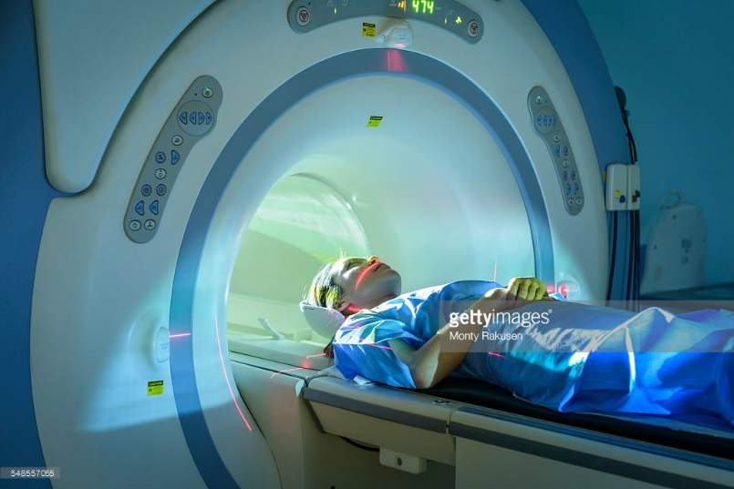

Credit:[Monty Rakusen](http://www.gettyimages.com/search/photographer?family=creative&photographer=Monty+Rakusen)

Creative #: 548557055

Figure 2. MRI (magnetic resonance imaging) sometimes is used to measure the size of a tumor.

<http://www.gettyimages.com/license/548557055>



Credit:[Johnny Greig](http://www.gettyimages.com/search/photographer?family=creative&photographer=Johnny+Greig)

Creative #: 623699550

Figure 3. Several reliable websites provide information related to breast cancer treatment. Beware of websites that promise cures or offer anything that sounds “too good to be true.”

<http://www.gettyimages.com/license/623699550>