Good morning, Susan.

Please see below the written permission to use the 2 images in this e-mail for the Land Trust EDIS document, which I know is currently in production.

Best,

Elizabeth F. Pienaar

Assistant Professor, Human Dimensions of Wildlife Conservation

Department of Wildlife Ecology and Conservation

University of Florida

Tel: 352-846-0630

E-mail: [efpienaar@ufl.edu](mailto:efpienaar@ufl.edu)

**From:** North,Benjamin W   
**Sent:** Wednesday, October 11, 2017 11:44 AM  
**To:** Pienaar,Elizabeth Frances  
**Subject:** Fw: Image permission for extension document on land trusts

Hi Professor Pienaar,

I contacted another land trust in Florida (the Conservation Foundation of the Gulf Coast) who just gave us permission to use the photos below which I think might be suitable for the extension document. I have also included my correspondence with them that provides written approval to use these photos. If need be, I can request for permission to use other photos on their website (it seems as thought they have quite a few good ones).

-Ben

<http://conservationfoundation.com/images/directory/Properties/Manasota_Scrub_lrg.jpg>

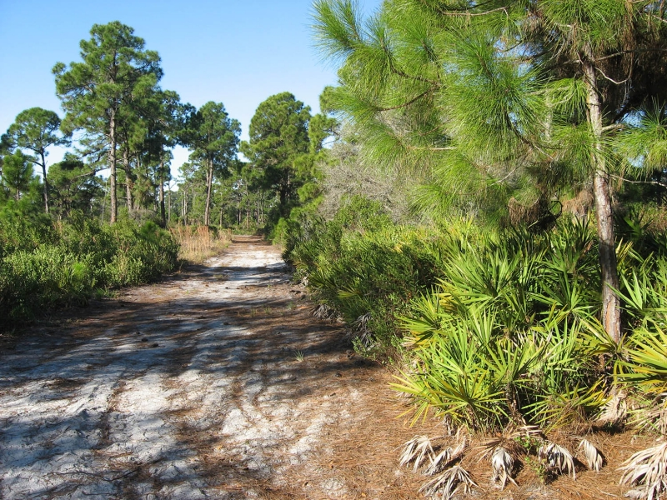

<http://conservationfoundation.com/images/directory/Properties/Warm_Mineral_Springs_Creek_lrg.jpg>

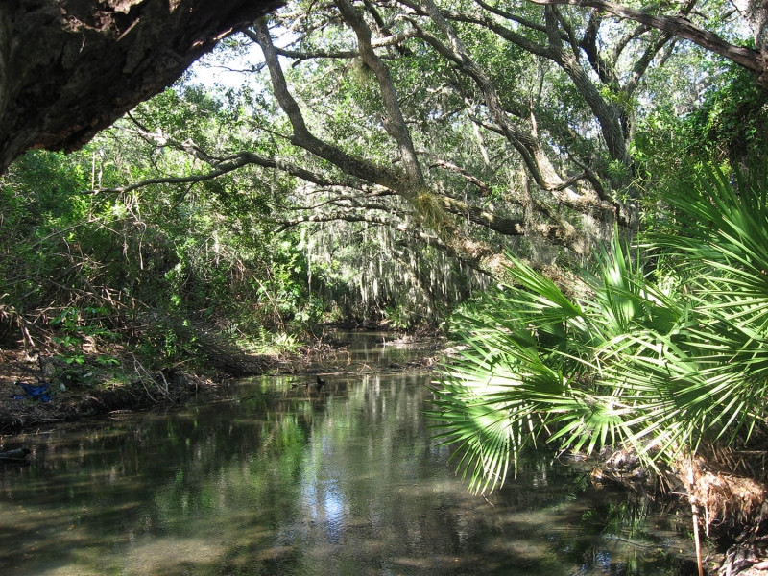

**From:** Suzanne Gregory <[Suzanne@conservationfoundation.com](mailto:Suzanne@conservationfoundation.com)>  
**Sent:** Wednesday, October 11, 2017 10:33 AM  
**To:** North,Benjamin W  
**Cc:** Pam Brownell  
**Subject:** Image permission for extension document on land trusts

Hi Benjamin,

You have permission to use the photos (except the one with people) shown below with credit to “Conservation Foundation of the Gulf Coast”.   If there are any others you want to use, please ask again.  Some of our photos require credit  to the photographer.

Best regards,

Suzanne

**Suzanne B. Gregory**

Director of Programs and Marketing

Conservation Foundation of the Gulf Coast

400 Palmetto Avenue  **I**  PO Box 902  **I**  Osprey, FL  34229-0902

t 941.918.2100  **I**  c 941.726.1688  **I**  f 941.918.2103

[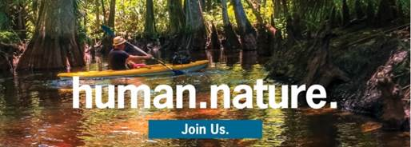](http://conservationfoundation.com/)

[***www.conservationfoundation.com***](http://www.conservationfoundation.com/)

***“Working with you to protect the bays, beaches, barrier islands and watersheds of Florida’s Gulf Coast.”***

**From:** North,Benjamin W [<mailto:b.north@ufl.edu>]   
**Sent:** Thursday, October 05, 2017 2:40 PM  
**To:** Info Account  
**Subject:** Image permission for extension document on land trusts

Dear Conservation Foundation of the Gulf Coast staff,

I am a PhD student at the University of Florida in the Wildlife Ecology and Conservation Department writing an extension document for the general public in Florida to better understand what land trusts are and how they function to protect land.

I came across the images provided in the links below on your website and I am hoping to use one of them to include in this document. Would you be willing to allow me to use one of these images in this extension document if I credit the Conservation Foundation of the Gulf Coast appropriately for this image? Thank you very much for any response or permissions you might be willing to provide.

Best,

Ben North

Ph.D. Student

Department of Wildlife Ecology and Conservation

University of Florida

<http://conservationfoundation.com/images/directory/Properties/CoralCreek3_lrg.JPG>

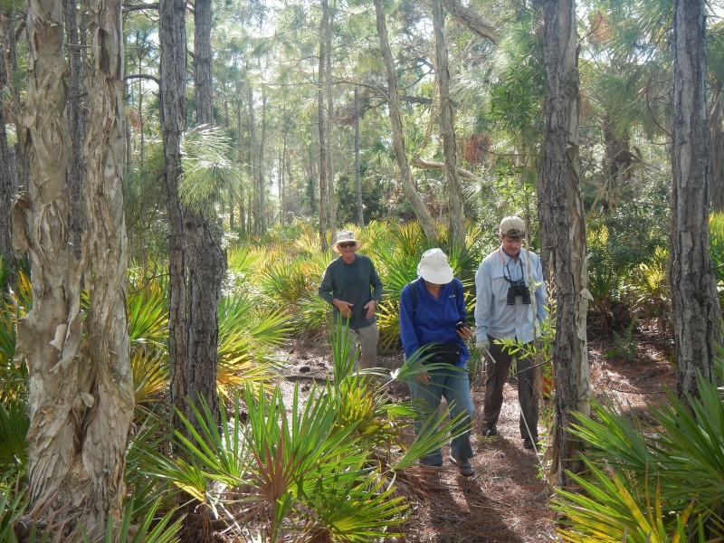

<http://conservationfoundation.com/images/directory/Properties/Manasota_Scrub_lrg.jpg>



<http://conservationfoundation.com/images/directory/Properties/Warm_Mineral_Springs_Creek_lrg.jpg>

